- Connecting to Compete 2010: Trade Logistics in the Global Economy. The International Bank for Reconstruction and Development // The World Bank–2010. – Washington, DC. – 50 p.
- http://nbuv.gov.ua
- Connecting to Compete 2007: Trade Logistics in the Global Economy. The International Bank for Reconstruction and Development // The World Bank. – 2007. – Washington, DC. – 38 p.
10. http://roshen.com
11. http://www.konti.com
12. http://www.nestle.ua

² ² ² ² ² ² ²

УДК 519.23:621.6.004.94

А. Д. Тевяшев, доктор технічних наук, завідувач кафедри прикладної математики
Харківського національного університету
радіоелектроніки
А. А. Мамедова, аспірант Харківського
національного університету радіоелектроніки
В. А. Фролов, аспірант Харківського
національного університету радіоелектроніки

MATHEMATICAL MODEL AND CALCULATION METHOD
QUASI-STATIONARY TRANSPORT AND DISTRIBUTION NATURAL GAS SYSTEMS

У статті наведено стохастичну модель квазістаціонарного неізотермічного режиму транспорту і розподілу природного газу в газотранспортних системах з багатонитковими лінійними ділянками та багатоцеховими компресорними станціями. Наведено метод розрахунку статистичних властивостей залежних змінних моделі від статистичних властивостей незалежних змінних.
В работе представлена стохастическая модель квазистационарного неизотермичес-
кого режима транспорта и распределения природного газа в газотранспортных системах с многониточными линейными участками и многоцеховыми компрессорными станциями. Приведен метод расчёта статистических свойств зависимых переменных модели от статистических свойств независимых переменных.
The paper presents a stochastic model of a quasi-stationary non-isothermal mode of transport and distribution of natural gas transportation systems with multilinear linear plots and a lot of craft compressor stations A method for calculating the statistical properties of the dependent variables of the model from the statistical properties of the independent variables.

Keywords. Transmission system, mathematical model, a quasi-steady non-isothermal mode, natural gas, a linear plot, compressor station, the statistical properties.
1. Introduction
Solution of the problem of analysis and optimization of the actual modes of gas transportation systems (GTS) is associated with the development of mathematical models that more adequately and in a wider range describe the actual modes of the TCA. One such model is a stochastic model of quasi-stationary non-isothermal mode of transport and distribution of natural gas in the GTA with multithread linear sections (MLS), and many craft compressor stations (CS). In this article we give a general stochastic model of quasi-stationary non-isothermal mode of transport and distribution of natural gas in the GTS with MLS and compressor stations (CS). This model explicitly takes
© А. Д. Тевяшев, А. А. Мамедова, В. А. Фролов, 2010
into account both the internal uncertainty of the parameters of technological elements of the GTS, and external uncertainty parameters of the processes of natural gas consumption by various categories of consumers. We consider the method of constructing the deterministic equivalent stochastic model of a quasi-stationary non-isothermal mode of transport and distribution of natural gas in the GTS and the approximate solutions obtained by co-nematode system of nonlinear and linear algebraic equations defined on a graph reflecting the structure of the GTS; and the method for calculating the statistical properties of the dependent variables model the statistical properties of the independent variables.
2. Mathematical modeling of stochastic quasi-stationary mode of natural gas transportation in GTS with MTS and MGP, CS
To build a general stochastic model of a quasi-stationary non-isothermal mode of transport and distribution of natural gas in the GTS with MLS and many CS will use the results obtained in [1]: stochastic models of the quasistationary mode of transport of natural gas pipeline and the stochastic model mode pumping unit (GPU). As a model of the structure of the GTS will use oriented connected graph G(V, E) [2], which is supplemented by a zero vertex and dummy arcs connecting this vertex with all inputs and outputs of the GTS, where () - a set of vertices, E- the set of arcs (). Choose a tree graph G(V, E) so that its branches have become real and fake parts of the arc corresponding to the input of GTS. Then the set of arcs of the graph E represented as a union of disjoint subsets of the following: the real sections ; fictitious sections on the network inputs ; fictitious sections on the network output , fictitious sections, connecting the input of the active elements with the zero point (fictitious additional network input) ; real tree branches ; real tree branches, which correspond to passive and active elements; real chords of the graph ; real chords of the graph which correspond to passive and active elements; fictitious branches of a tree, which correspond to inputs ; branches of a tree on the inputs of the network with a preset flow , pressure and temperature ; chords of the graph, which correspond to inputs ; chords of the graph of the network inputs with the preset flow , pressure , temperature ; fictitious chords which correspond to outputs ; fictitious chords on the outputs of the network with a preset flow pressure , temperature ; fictitious chords of the graph, corresponding to fictitious additional network input (arcs connecting the input of the active elements with the zero point) with a preset flow . The quantity is considered preset if it is a normally distributed random variable with known expectation and variance.
We introduce the following notation: the number of nodes, in which pressure is preset – number of branches, in which flow is preset – the number of nodes, in which temperature is preset – the number of branches with active elements –
Given quantities are random variables with normal distribution law and represented by their mathematical expectations and variances.
Then the stochastic model of quasi-stationary non-isothermal mode of transport and distribution of natural gas in the GTS can be expressed as follows:

(1)
(2)
(3)
(4)
(5)
(6)
(7)
(8)
, (9)
(10)
(11)
(12)
(13)
(14)

where:
( – marks the preset quantities);
– the set of elements on which the gas comes into the -th node, and is bled from it, respectively;
– Cyclomatic matrix element, located at the intersection of the r-th row and the i-th column;
– Random variables, characterizing the pressure at the beginning and the end of the i-th arc;
– Random variables, characterizing the temperature at the beginning and the end of the i-th arc;
– Random variable characterizing the commercial flow of i-th arc;
– Random variable characterizing the assessment ratio of hydraulic resistance of pipeline:
(15)

where – random variable characterizing the assessment ratio of the relative density of natural gas in the air, – random variable characterizing the estimation of the average temperature and average density of natural gas of i-th arc, – random variable characterizing the assessment of effectiveness ratio i-th pipeline.
– random variable defined by the expression:

(16)

where – random variable characterizing the estimate of the average values of the coefficient of heat transfer from the gas in the ground on the – th section of the pipeline, - a random variable characterizing the estimate of the coefficient of the specific heat of natural gas;
– random variable characterizing the approximation estimates for the coefficients describe the degree of compression of GPA from the commercial flow for GPA-owned i-th arc:

, (17.1)
, (17.2)
(17.3)

where:

(18.1)
(18.2)
(18.3)
where and – random variables characterizing the estimates of coefficients of approximation polynomials of the degree of compression GPA first and second degree, respectively, at
– random variables characterizing the above assessment of the relative speed drive of i-th GPA:

, (19)
, (20)
– random variable characterizing the assessment polytropic efficiency:

(21)
– random variable characterizing the performance evaluation of the reduced vo-
lume of i-th GPA:
(22)

Stochastic model of quasi-stationary non-isothermal mode of transport and distribution of natural gas transportation systems (1)–(22) takes into account almost all sources of internal and external uncertainties modes TCA and allows enough to adequately analyze and simulate a wide class of quasi-stationary modes of the GTS. Of greatest interest, this model is to optimize the planned modes GTS. In this case the optimal plan of GTS at a given time interval is represented as mathematical expectations and variances of parameters of flows of natural gas (pressure, flow, temperature) on the inputs and outputs of the GTS, expectations and variances of operational parameters (speed drives) GPA. To calculate the mathematical expectation of flow parameters of natural gas for each real portion, and at every entrance and exit of the GTS is necessary to construct a deterministic equivalent stochastic model of a quasi-stationary non-isothermal mode of transport and distribution of natural gas transportation systems (1)–(14).
3. Construction of the deterministic equivalent stochastic model of quasi-stationary non-isothermal mode of transport and distribution of natural gas transportation systems
To construct a deterministic equivalent stochastic model of a quasi-stationary non-isothermal mode of transport and distribution of natural gas transportation systems ((1)–(14) will replace all the random quantities in the system of equations (1)–(14) of their assessments in the form of conditional expectations. In because of the nonlinearity of the system of equations (1)–(14), such replacement would result in the right side of equations (1)–(14) of non-zero residuals, the sign and magnitude of which, according to Jensen's inequality [3], determined by the degree of convexity (concavity) of implicit functions of the variables defining the system of equations (1)–(14). As shown by our studies, the numerical value of these residuals is comparable with the magnitude of error in the numerical solution of equations (1)–(14). Therefore, without loss of genera-
lity , residuals of the deterministic equivalent stochastic model of a quasi-stationary non-isothermal mode of transport and distribution of natural gas transportation systems (1)–(14) will be neglected. It can be shown [3] that in this case, the deterministic equivalent stochastic model of a quasi-stationary non-isothermal mode of transport and distribution of natural gas in the transmission system (1)–(14) will coincide with the steady-state model of the flow of gas pipeline networks with active elements, in which the boundary conditions and unknown parameters are represented by their conditional expectation. A numerical algorithm for solving systems of equations of the deterministic equivalent stochastic model of a quasi-stationary non-isothermal mode of transport and distribution of natural gas transportation systems is given in [3].

, ,
, ,
, ,
, ,
, ,
, ,
where the parameters marked feature of the above are estimates in the form of mathematical expectation of the random variables model presented in section 2.
4. Assessing the relation of statistical properties of the dependent and the independent variables in the stochastic model of the quasi-stationary non-isothermal natural gas transportation mode in the gas transportation systems
Formal statement of the problem of assessing the statistical properties of the dependent variables in the stochastic model of the quasi-stationary non-isothermal natural gas transportation mode in the GTS, is the necessity to determine the numerical characteristics of random variables, which are the solution of the deterministic analogue of the functional relationships (1)–(14) supplemented by equations (15)–(22):

(23)

We define the vector of dependent variables as and the vector of independent variables as Then the solution takes on the following form:

(24)
where N – number of calculated parameters in the general case equal to N = (2n + 5m + 7gl – 4ml – – nl – l1), and – number of the preset parameters.
Since the system (24) is given implicitly, and the conditions of the theorem “on the existence and differentiability of the implicit functions determined by a system of functional equations” [6, 7] hold, we assume that there exists a functional dependence between random variables that are system's dependent and independent parameters, which is defined by the model (1)–(22).
As a result of applying the method of linearizing the function of several random variables [6, 7], as well as the subsequent applying the properties of the numerical characteristics of functions of random variables to the resulting expression, we obtain the following dependencies of the statistical characteristics (excluding random variables correlation):
(25)
(26)
To determine the values of the expectations (25) we need to solve the system of equations (23), relative to the variables – the random variates at the point, corresponding to the expectations of gas flow parameters in the network,
To find the variance (26) it is necessary to calculate the partial derivatives used in dependencies. Since the system (24) is implicit, and therefore it is impossible to find its general analytical solution, a method for calculating the partial derivatives for a system of implicitly defined functions follows.
5. The method of calculating the partial derivatives of implicitly defined functions
Since for the system of implicitly defined functions being considered (24), at points, which correspond to optimal and average values of the network parameters, the conditions of the theorem “On the existence and differentiability of the implicit functions determined by a system of functional equations” hold, then the partial derivatives , can be found, according to the general form of the partial derivative of implicitly defined function:

(26)
where – Jacobian of the system of implicitly defined functions, which has the form:
, (27)
and – determinant of the matrix obtained from (4.48) by replacing the j-th column with the derivatives of the corresponding functions with respect to the variable Y_{j}, .
6. Partial derivatives
Let’s denote a couple more classes of functions, as the dependences (15)–(22) are included in the system (23) in exactly that form.
(28)
, (29)
(30.1)
(30.2)
(30.3)
(31.1)
(31.2)
(31.3)
(32)
(33)
(34)
(35)
for expressions (30.1–35)
Analytical form of partial derivatives and ( ), is presented below [8, 9]:
Partial derivatives take on the form:
– for equation of kind (1):
- for equation of kind (2):
- for equation of kind (4)–(6):
- for equation of kind (13):
- for equation of kind (14):
- for equation of kind (16):
- for equation of kind (22):
Partial derivatives () equal:
- for equation of kind (1)–(7):
Partial derivatives () equal:
- for equation of kind (1)–(7):

Partial derivatives equal:
- for equation of kind (1):
- for equation of kind (13):
- for equation of kind (15):
Partial derivatives () equal:
- for equation of kind (1), (3)–(7):
,
- for equation of kind (2):
where , ,
– for equation of kind (3)-(7):
Partial derivatives equal:
- for equation of kind (7):
,
- for equation of kind (10):
- for equation of kind (13):
- for equation of kind (14):
Partial derivatives equal:
- for equation of kind (10):
- for equation of kind (13):
- for equation of kind (14):
- for equation of kind (22):
Partial derivatives equal:
- for equation of kind (9):
- for equation of kind (10):
- for equation of kind (12):
- for equation of kind (17.2):
- for equation of kind (17.3):
- for equation of kind (19):
- for equation of kind (22):
Partial derivatives for equation of kind: (9)–(10),
Partial derivatives equal:
- for equation of kind (9):
- for equation of kind (12):
- for equation of kind (16):
Partial derivatives equal:
- for equation of kind (21):
- for equation of kind (22):
Partial derivatives equal:
- for equation of kind (12):
- for equation of kind (15):
Partial derivatives () equal:
- for equation of kind (1), (3)–(7):
- for equation of kind (2):
Partial derivatives () equal:
- for equation of kind (1), (3)–(7):
- for equation of kind (2):
Partial derivatives () equal:
- for equation of kind (1), (3)–(7):
- for equation of kind (2):
Partial derivatives equal:
- for equation of kind (14):
- for equation of kind (17.1):
Partial derivatives equal:
- for equation of kind (14):
- for equation of kind (17.2):
Partial derivatives equal:
- for equation of kind (14):
– for equation of kind (17.3):
Partial derivatives equal:
– for equation of kind (15):
Partial derivatives for equation of kind (16):
Partial derivatives equal:
- for equation of kind (17.1):
- for equation of kind (17.2):
- for equation of kind (17.3):
- for equation of kind (19):
The rest partial derivatives for equation of kind (18.1):
The rest partial derivatives for equation of kind (18.2):
The rest partial derivatives for equation of kind (18.3):
And partial derivatives for equation of kind (17.1)–(17.3) respectively equal:
Partial derivatives equal:
- for equation of kind (10):
- for equation of kind (20):
Partial derivatives equal:
- for equation of kind (20):
- for equation of kind (21):
The rest partial derivatives for equation of kind (21) equal:
The rest partial derivatives and
7. Modeling results
Let us consider the following example. We’ll perform the hydraulic calculation for a section of the gas tranport system in the form of a main gas pipeline, which includes compressor section with five gas pumping units. Figure 1 shows the corresponding computational graph, consisting of 16 nodes and 21 branches, 5 of which are active (arcs № 14–18) of pipes: km, km, km, the diameters m, m.
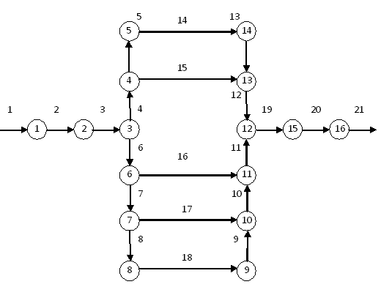

Figure 1. MGP Graph

Suppose the maximum deviations of preset parameters are as follows:
– commercial flow – , where – relative error in measuring commercial flow;
– for pressure – , where – relative error of pressure measurements;
– for temperature – , where – relative error of temperature measurements.
– for efficiency factor – , where – relative error of measurements.
– for the average coefficient of the gas – , where – relative error of measurements.
As the mathematical expectations of random variables at the inputs the following parameters , , , were taken. Next, we determined , , , as a result of the calculations the expectations (13)–(16), were obtained, among which the study of random variables is of a special interest. That is, the calculated parameters for nodes 1 and 16 (Figure 1): , , ).
To establish the dependence between the variances of random variables and variances of parameters we used the method presented in Section 3. Below are the charts of some of them– each such chart shows two dependencies: in the first case partial derivatives were calculated analytically (dashed line), as described in Section 4, while in the second case-numerically (solid line).
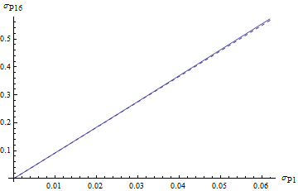 | 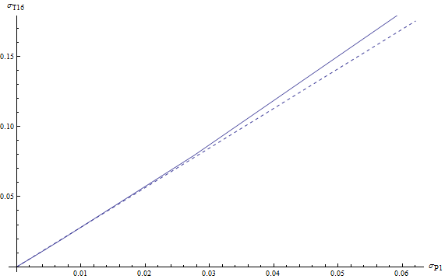
Figure 2. Dependence between the variances  of output pressure and variances input  pressure  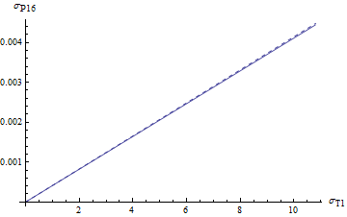 | Figure 5. Dependence between  the variances of output temperature  and variances input pressure  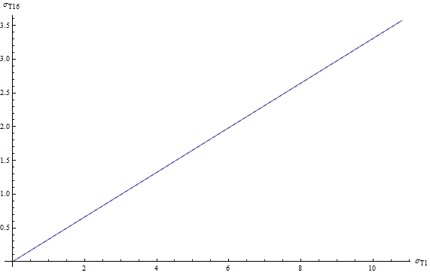
Figure 3. Dependence between the variances  of output pressure and variances input  temperature  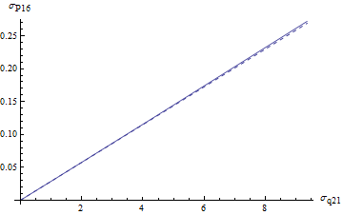  Figure 4. Dependence between the variances  of output pressure and variances output  commercial flow | Figure 6. Dependence between  the variances of output temperature  and variances input temperature  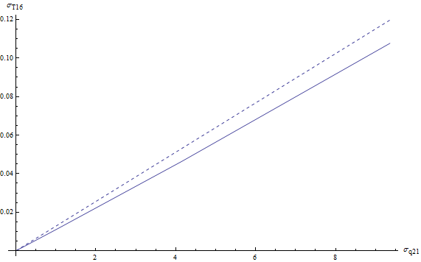  Figure 7. Dependence between the variances  of output temperature and variances  input pressure
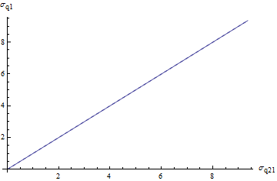
Figure 8. Dependence between the variances of input commercial flow and variances output commercial flow

Conclusions.
This paper addresses the problem of mathematical modeling of stationary non-isothermal modes of the natural gas transportation with the multithread LS and multishop CS. The novelty of this work lies in the fact that for the first time the problem of mathematical modeling of stochastic quasi-stationary non-isothermal mode of natural gas transportation over the network with multithread LS and multishop CS, and the problem of assessing the relation between the statistical properties of the dependent and independent variables in presented model was solved. Practical significance is that these models provide upper and lower bounds for ranges of gas flow parameters at any GTS node for a given level of external stochastic disturbances.

Literature
1. Евдокимов А. Г. Потокораспределение в инженерных сетях / Евдокимов А. Г., Дубровский В. В., Тевяшев А. Д. – М. : Стройиздат, 1979.
2. Евдокимов А. Г. Оперативное управление потокораспределением в инженерных сетях / А. Г. Евдокимов, А. Д. Тевяшева. – Х. : Вища школа, изд-во Харьк. ун-та, 1980.
3. Сарданашвили С. А. Расчетные методы и алгоритмы (трубопроводный транспорт газа) / Сарданашвили С. А. – М. : ФГУП, Нефть и газ, 2005. – С. 577.
4. Нормы технологического проектирования магистральных газопроводов // Открытое акционерное общество ГазПром, Общество с ограниченной ответственностью “Научно-исследова-
тельский институт природных газов и газовых технологий” ВНИИГАЗ. – Москва, 2004.
5. Волков И. К. Случайные процессы / Волков И. К., Зуев С. М., Увяткова Г. М. – М. : Издательство МГТУ им Н. Э. Баумана, 1999. – С. 448.
6. Тевяшев А. Д. Оценка статистических характеристик расчетных параметров режимов функционирования ЭЭС, в зависимости от статистических характеристик выходных данных / Тевяшев А. Д., Тимофеева Т. Б., Синельникова О. И. // Вестник Харьковского государственного университета сельского хозяйства, по материалам научно-практической конференции “Проблемы энергообеспечения и энерхосбережения а АПК Украины”. – Х., 2001.
7. Фихтенгольц Г. М. Курс дифференциального и интегрального исчисления / Фихтенгольц Г. М. – М. : Наука, 1969.
8. Тевяшев А. Д. Стохастическая модель квазистационарного неизотермического режима транспорта природного газа в газотранспортных системах / А. Д. Тевяшев, А. А. Мамедова, В. А. Фролов // Автоматизированные системы управления и приборы автоматики. – 2009. – № 149.
9. Тевяшев А. Д. Математическое моделирование стохастического квазистационарного неизотермического режима транспорта природного газа в газотранспортных системах / А. Д. Тевяшев, А. А. Мамедова, В. А. Фролов // Восточноевропейский журнал передовых технологий. – 2010. – № 1/7 (43). – С. 30.

