UDC 004.4:656.1
WEB APPLICATION FOR TRANSPORT INFRASTRUCTURE SIMULATION
Alexander Firsov , Mykola Mormul , Yulia Ulyanovskaya ,
Alexander Shchytov , Dmytro Shchytov
Purpose. The work develops a web application for simulation modeling of road traffic at an intersection in order to optimize traffic flows. Design / Method / Approach. The study uses an engineering and technological approach that involves designing and implementing a web application taking into account the architectural principles inherent in complex object modeling systems. Theoretical implications. The conceptual model allows adapting existing principles of modeling complex systems (in particular, transport networks) to the formats of web-oriented applications. Conclusions. Alternative parameters and sequential algorithms for the functioning of this model have been developed. Detailed flowcharts of each stage have been constructed and the best solution to the problem has been selected. Practical implications. As a result of the implementation of the architecture, a functional prototype has been created that allows modeling traffic in the current time mode. It can be used to analyze the quality of the organization of transport flows, as well as by state institutions, city administrations and project organizations for a visual representation of the transport network or the practical implementation of a functional prototype. Of particular importance is its use in the military sphere as a tool for situational analysis, logistics planning and simulation for making effective decisions in dynamic and dangerous conditions. The value of the study is the basis for the practical application of information technologies in the field of infrastructure planning. The developed model was successfully tested on the example of the multimodal transport system of the city of Dnipro and the organization of road traffic in the city with 5 distributions of transport networks: normal, uniform, decreasing (exponential), increasing, based on real (empirical) data. Research limitations / Further research. The study is limited by the set of input data and the lack of consideration of informal factors that may affect traffic. Further directions of the real-time scenario include: integration with real sources of transport data; implementation of nonlinear, stochastic or neural network approaches; inclusion of modules for assessing network load, CO₂ emissions, impact on the environment and economy of the city. The proposed tool can be used to analyze the efficiency of traffic management, assess the impact of infrastructure changes or test transport policies. Originality/value. The originality of the work lies in the combination of web development and transport modeling approaches in a single architecture focused on interactive simulation of infrastructure objects. Research includes: integration with real sources of transport data; inclusion of modules for assessing network load in real time. Тип статті. Practically oriented.
Keywords: bandwidth, network, transport, simulation modeling, web application.

Мета. В роботі розробляється веб-додаток для імітаційного моделювання дорожнього руху на перехресті з метою оптимізації транспортних потоків. Дизайн / Метод / Підхід. У дослідженні застосовано інженерно-технологічний підхід, що передбачає проєктування та реалізацію веб-додатку з урахуванням архітектурних принципів, властивих системам моделювання складних об’єктів. Теоретичні наслідки. Концептуальна модель дозволяє адаптувати існуючі принципи моделювання складних систем (зокрема, транспортних мереж) до форматів веб-орієнтованих додатків. Висновки. Розроблено альтернативні параметри і послiдовнi алгоритми функціонування даної моделі. Побудовано детальнi блок-схеми кожного етапу та обрано найкращий варiант розв’язання задачi. Практичні наслідки. У результаті реалізації архітектури створено функціональний прототип, який дозволяє моделювати транспортні потоки у поточному часовому режимі. Його може бути використано для аналізу якості організації транспортних потоків, а також державними установами, міськими адміністраціями та проєктними організаціями для візуального представлення транспортної мережі чи практичного впровадження функціонального прототипу. Особливого значення набуває його застосування у військовій сфері як інструмент ситуаційного аналізу, логістичного планування і симуляції для прийняття ефективних рішень у динамічних і небезпечних умовах. Цінність дослідження складає підґрунтя для практичного застосування інформаційних технологій у сфері інфраструктурного планування. Розроблену модель було успішно протестовано на прикладі мультимодальної транспортної системи міста Дніпро та організації в місті дорожнього руху при 5 розподілах транспортних мереж: нормального, рівномірного, спадного, зростаючого, на основі реальних (емпіричних) даних. Обмеження дослідження / Подальші дослідження. Дослідження обмежується набором вхідних даних та відсутністю врахування неформальних факторів, що можуть впливати на трафік. Подальші напрями сценаріїв дорожнього руху на перехресті в режимі реального часу включають: інтеграцію з реальними джерелами транспортних даних; впровадження нелінійних, стохастичних або нейромережевих підходів; включення модулів оцінки навантаження на мережу, викидів CO₂, впливу на екологію та економіку міста. Запропонований інструмент може бути використано для аналізу ефективності організації дорожнього руху, оцінки впливу інфраструктурних змін або тестування транспортних політик. Оригінальність/цінність. Оригінальність роботи полягає у поєднанні підходів веб-розробки та транспортного моделювання в єдиній архітектурі, орієнтованій на інтерактивну симуляцію інфраструктурних об’єктів. Дослідження включає інтеграцію з реальними джерелами транспортних даних; включення модулів оцінки навантаження на мережу у режимі реального часу. Тип статті. Практично-орієнтована.
Ключові слова: пропускна здатнiсть, мережа, транспорт, iмiтацiйнe моделювання, веб-додаток.

Today, the transport sector is facing an acute problem due to the constant increase in the number of transport facilities, the need to increase their reliability and safety. Every year, the problems of the sector become more acute due to the progress and spread of transport. The urban road network contains a large number of intersections of individual roads and highways, which are most often at the same level. There is an intersection of vehicle and pedestrian flows, which are called conflicting. With an increase in the density of conflicting vehicle and pedestrian traffic, the likelihood of committing traffic violations (traffic accidents) increases.
A common problem for all countries, regardless of the level of motorization, is the disproportion between the growth rate of the number of automobile fleets and the length of the street and road network. This circumstance contributes to its oversaturation with traffic flows, complicates traffic conditions, reduces the speed of communication, and delays at intersections. Due to the insufficient capacity of the elements of the street and road network, traffic jams arise on the roads. All this, in turn, requires an increase in the costs in this industry for the support and development of the transport network, which can be reduced by simulation modeling.
Building models allows you to identify bottlenecks in transport networks, design transport infrastructure to optimize the city's traffic flow, thereby reducing the cost of maintaining road networks and increasing the safety of residents. In addition, using traffic flow modeling, you can determine the future requirements of the city in the further expansion of the transport network.
In the traffic flow management system, the object of study is the transport process associated with road traffic on a separate section of the city's transport network. At the same time, driver behavior is diverse and not always predictable, which complicates the analysis of such a system.
The use of simulation modeling software significantly speeds up the study of traffic flows, allowing you to take into account various scenarios of road situations and behavioral factors of road users, which, in turn, reduces the cost of conducting research by reducing the time and number of errors during analysis. The transition from traditional software to a web-based application opens up a number of important advantages. First of all, accessibility is a key characteristic of a web application. The user can work with it from any gadget that has a web browser installed, which is usually available by default on most modern devices. In addition, the web application does not require installation, which further reduces the organizational and technical costs associated with its implementation. The simplicity of the interface and intuitive interaction with the user allow you to work with the application without specialized training, which expands the range of potential users and lowers the entry threshold. Another advantage is low system requirements. The web application does not require expensive or specialized equipment, and both a personal computer and a mobile device can be used for access, which is especially relevant in conditions of limited resources or field research.
The purpose of the work is to create an algorithm for simulating traffic at an intersection. The task includes building a UML project of the developed web application, which could be quickly and easily integrated into already used systems.
The scientific novelty of the research is as follows:
1) a web service architecture was proposed, which combines a Java library for Petri object modeling with a web-oriented graphical editor. This ensures effective development of simulation models without the need to connect additional software modules to local machines;
2) a visual environment was developed that allows creating Petri object models at two levels: development of a stochastic Petri net and its use to create Petri objects;
3) the created model was tested on a specific transport model of the city with an analysis of the obtained results of the distribution of the transport network.
Source review. Many scientists have contributed to the study of transport industry problems. Dolgushin D. Yu. and Myznikov T. A. tried to solve problems using cellular automata. Buslaev O. P., Novikov O. V., Prikhodko V. M., Tatashev A. G., Yashina M. V. used graphs with a dynamic approach to modeling [15]. Cherednichenko K. V. investigates the root causes of traffic jams and proposes a tool for optimizing the urban network using the example of Kyiv traffic interchanges [3]. The paper [17] presents simulation modeling of the operation of a conditional controlled intersection in the PTV VISSIM program. The authors of the study [11] develop a generalized complex criterion for the efficiency of traffic organization for a T-shaped unregulated intersection. Lyashchuk O. L. and colleagues investigate mechanisms for increasing the efficiency of the functioning of an unregulated intersection with a roundabout [9]. Bugaev I. S. with his team and Khitrov I. S. evaluate the effectiveness of implementing traffic calming measures at a regular intersection and with a roundabout [2], [7].
These problems were also addressed by: Kovbasenko S. V., Sochnev A. N., Skaletsky V. V., Arak A. O., Mayorov G. N., Ligum Yu. S., Symonenko V. V., Fetysov V. A., Gutarevich S. Yu., Shirochenko V. A., Spirin I. V., Kuleshova A. V., Antoshvili M. E., Pitsyk M. G., Artinov A. P., Karnaukhova V. O., Yeremeyeva L. O., Komov P. B., Komov O. B., Firsov O. D., Pikulin D. O. and other scientists [12].
Among the foreign researches of recent years on this topic, the following should be noted. The study “Data-Driven Traffic Simulation for an Intersection in a Metropolis” [20] presents a new environment for modeling traffic at urban intersections, which uses real data on vehicle trajectories to train trajectory prediction models. This allows modeling agent interactions and environmental constraints that are difficult to account for with traditional methods. The work “TraInterSim: Adaptive and Planning-Aware Hybrid-Driven Traffic Intersection Simulation” proposes a new adaptive hybrid modeling method for simulating traffic scenarios at intersections. The method combines a data-driven optimization approach with a speed continuity model, which allows agents to avoid collisions while taking into account the planning of other participants [10]. And the paper “Developing a Sustainable Traffic Management Framework Using Machine Learning Algorithms” aims to develop a sustainable transportation framework that uses machine learning algorithms to predict and minimize fuel consumption as a measure of environmental impact at densely populated intersections [18].
The study “Harnessing Digital Twin Technology for Adaptive Traffic Signal Control” presents an adaptive traffic signal control framework based on digital twin technology to improve intersection performance and user satisfaction. Algorithms DT1 and DT2 use real-time vehicle trajectory data and future demand forecasts to adapt signals in real time [4].
The study “Development of Mixed Traffic Microsimulation Model Calibration for Heterogeneous Traffic Conditions” develops an approach to calibrate the VISSIM model for heterogeneous traffic conditions. The methodology was applied to two intersections in Ho Chi Minh City, Vietnam, and showed that the calibrated model can accurately reproduce traffic characteristics [16].
Currently, there are several software tools that implement simulation modeling of traffic flows: AIMSUN; PTV Vissim; Bentley Systems; Aimsun Next; Actor Piligrim and others. These software products allow you to model various aspects of traffic - from individual driver behavior to general traffic in urban agglomerations. They are widely used for analyzing infrastructure solutions, optimizing traffic light regulation, and assessing the impact of road works.
The company "A+S Ukraine" [13] developed a multimodal transport model of the city of Dnipro, presented in 2020 [1], thanks to which statistics were collected for this work.
Methods. This study uses a comprehensive approach that combines engineering, software, and system methods for analyzing, designing, and implementing the architecture of a web application. The main methods include:
1. The structural and functional analysis method, which was used to study existing architectural solutions in the field of transport modeling and identify their advantages and disadvantages.
2. The system modeling method according to the methodology [3], [19], which allowed building a general conceptual model of the architecture of the web application.
3. The prototyping method, which was used to create a functional web prototype of the application that simulates the behavior of traffic flows in given scenarios.
4. The agent modeling method, which was implemented to simulate the interaction of road infrastructure objects (vehicles, traffic lights, intersections) at the level of model logic.
5. Web programming and interface design methods, in particular the use of frameworks and technologies (HTML/CSS, JavaScript, Python, REST API), which ensured the implementation of an adaptive, accessible and scalable solution.
6. Methods of visualization and interpretation of results, which were used to present simulation results in a graphical form (tables, diagrams, maps).
7. Empirical approach - testing the created application on a test model of the transport network in order to assess the functionality of the architecture, its performance and ease of use.
Result. The creation of a UML project begins with the construction of a use-case diagram for the web application, from which it is possible to see all possible actions in the project by the user.
Based on the use-case diagram, the main actor(s) of the system and their interaction with the functionality of the web application are determined. This allows you to structure the requirements for the system and clearly outline the boundaries of responsibility of each participant.
Also, technical tasks for developers are formed based on the diagrams, which significantly simplifies the process of implementing a web application and reduces the risk of errors when implementing the functionality (Fig. 1).
After this stage, usage scenarios are detailed by building activity, sequence, and class diagrams.

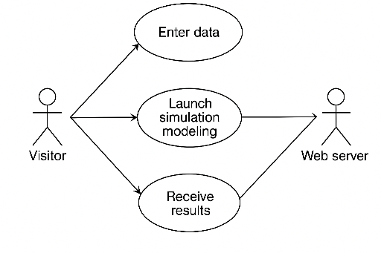
Fig. 1. Use case diagram
The main class is Crossroads, and all others are required for its operation and are default classes of the JavaScript language.
The #setSizes() function was created to set the sizes of the elements used. The #createRoads() function was invented to create road objects.
The color of traffic lights at intersections is switched using the #updSignals() function.
The #drawScene() function was built to display the so-called road map. Drawing a road is a separate process that is simulated by the #drawRoad() function. It takes into account the width and length of the road, the number of lanes.
The program also implements the logic of car movement and their interaction with traffic lights. Cars are generated in accordance with the specified parameters and respond to changes in traffic light signals, stopping or continuing to move on a green light, have an initial position, speed and direction of movement, and change their behavior depending on the traffic situation. The possibility of traffic jams at intersections with high traffic intensity, the presence of a previous car in the lane is also taken into account: in case of danger of collision, the system automatically reduces speed or stops the vehicle to maintain a safe distance. Thus, not only the basic traffic flow is simulated, but also the elementary behavior of drivers in real road conditions.
The process of simulating the intersection is initiated by the user calling the static function start().
Drawing an intersection is a complex process that depends on many conditions, including: the type of intersection (controlled or not), the number of lanes, the presence of pedestrian crossings, safety islands, directions of traffic flows, signaling, and road marking features. In addition, for realistic visualization, it is necessary to take into account scaling, map orientation, and the possibility of integration with geodata (for example, via OpenStreetMap). The #drawCrossroad() function displays this process.
Another complex process with a large number of conditions is the process of generating vehicles, which depends on a number of factors: traffic intensity on a specific section, type of vehicle (car, truck, public transport), route, time intervals (for example, rush hour), randomness or regularity in the appearance of new objects in the system, speed limits on relevant sections of the road, compliance with traffic rules (observance of traffic lights, priority signs, rules of overtaking, rebuilding and passing intersections). When developing a web application, it is necessary to implement a mechanism for dynamic generation of transport units, consistent with traffic rules and flow logic. It is also necessary to take into account speed limits, turning priorities, interaction with pedestrians (taking into account stops before pedestrian crossings, delays when pedestrians appear, maintaining a safe distance, unexpected violations of the rules by them) and relevant scenarios of road situations (road works, accidents, detours, weather conditions, changing road conditions).
The model should automatically create transport units on starting sections with given parameters (speed, type, route), as well as synchronize their behavior with other road users - this will allow to obtain a realistic, adaptive simulation of the road situation.
To implement the logic of switching the colors of traffic lights at intersections according to given time intervals, an appropriate time diagram was built, which displays the sequence of signal changes (green, yellow, red) for each lane or direction of movement, allowing to synchronize traffic flows and avoid conflict situations. The minimum and maximum duration values ​​of each signal phase have also been taken into account, which correspond to the real traffic requirements for different types of intersections (with different flow intensities). In the event of excessive traffic congestion, the possibility of adaptive regulation of the green signal time is provided, which allows increasing throughput and reducing the likelihood of congestion (Fig. 2).
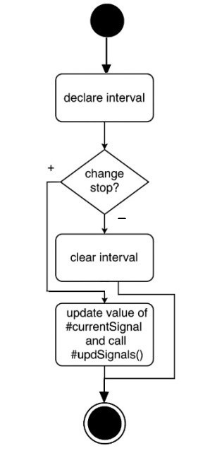

Fig. 2. Diagram of the #signal() function
Updating the constructed road scene map is carried out by calling the #tick() function according to the set frame rate. This method is responsible for the sequential change of the states of simulation objects over time, ensuring smooth visualization and synchronism of the actions of all model elements. The operation of this function is shown in the diagram (Fig. 3).
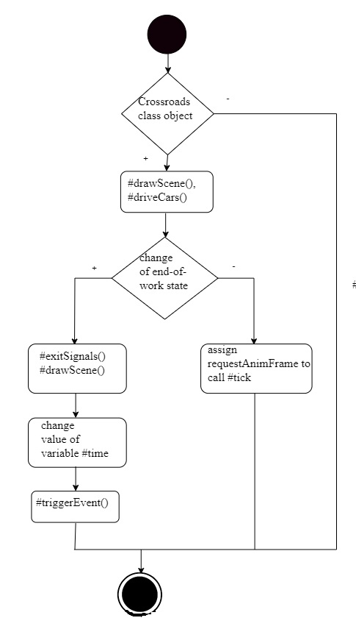
Fig. 3. Diagram of the #tick() function
The task of car distribution time is performed by a separate function #roadSetCarsDelay(),which determines the intervals of appearance of new vehicles on the road, taking into account the given traffic intensity.
A diagram was constructed to display the process of drawing a car in the function #drawCar(),which demonstrates the main stages of generating a car object, its positioning on the roadway and subsequent updating of coordinates while driving, which allows you to clearly trace the logic of the entire animation system (Fig. 4).
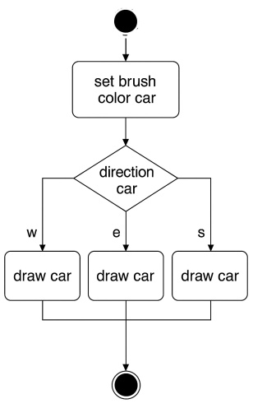
Fig. 4. Beginning of the #driveCars() function diagram
One of the most complex processes in a web application is the modeling of vehicle traffic, as it involves observing a large number of logical and physical conditions: traffic rules, priority at intersections, following distance, speed limits, behavioral reactions to other vehicles, traffic light conditions, interaction with pedestrians and other elements of the road infrastructure.
For correct simulation, a dynamic decision-making system for each vehicle should be implemented, taking into account both current road conditions and predicted actions of other road users.
The logic of vehicle movement in the web application includes: following the route according to the specified coordinates with orientation correction; reacting to traffic lights and stopping before the stop line at a red signal; avoiding collisions by maintaining a safe distance to other vehicles; smooth turns with speed and angle adjustment; controlling the speed of movement depending on the situation (traffic lights, restrictions, obstacles); taking into account priorities at intersections for safe interaction with other flows. The state of each vehicle is updated in each frame by calling the #tick() function.
Each vehicle moves along a predefined route, which is represented as a set of points (coordinates) or lines. The trajectory can be linear (straight movement) or curvilinear (turn). The algorithm constantly calculates the direction to the next route point and adjusts the vehicle’s orientation accordingly. If the deviation from the optimal trajectory exceeds an acceptable threshold, the system automatically makes adjustments to the steering angle or speed to return the vehicle to the planned route.
In the case of curved movement, the turning radius, speed, and possible obstacles are taken into account. The system provides for a smooth change of direction to avoid sudden maneuvers that can lead to loss of control of the vehicle.
The algorithm also takes into account the current position of the vehicle, obtained from GPS or positioning sensors, and combines this data with the route map. If a significant difference is detected between the actual position and the planned point, the trajectory is recalculated taking into account the new coordinates. To ensure safety and adaptability in a real environment, the algorithm includes an obstacle detection module. Using sensors (lidars, cameras or ultrasonic sensors), the system recognizes objects on the road - pedestrians, other vehicles, stationary objects - and reroutes or reduces speed to avoid a collision. To simplify the logic of vehicle movement, a separate check for the presence of a car in front of the intersection has been allocated, which allows for timely changes in the behavior of the object (for example, stopping, reducing speed or preparing for a turn). To illustrate this process, a logic diagram has been constructed that illustrates the decision-making algorithm when approaching the intersection (Fig. 5).

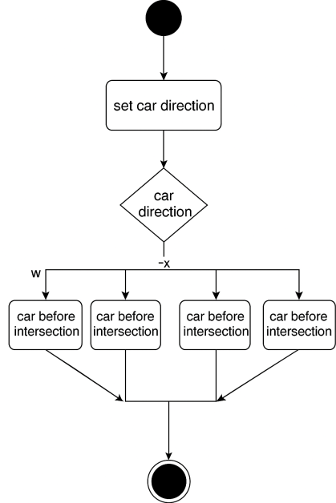

Fig. 5. Diagram of the #carCheckCrossroad() function
In addition, a diagram was constructed that reflects the process of checking whether the previous car is at the intersection or not, as well as the actions that need to be taken in response to one or another option.
This approach allows the model to correctly respond to situations when the car cannot continue driving through a busy intersection, ensuring compliance with traffic rules and preventing blockage of road network nodes. This, in turn, increases the overall efficiency and safety of the traffic flow in the model. Thanks to this algorithm, it is possible to avoid the so-called “junction congestion”, when several vehicles simultaneously try to enter the intersection, unable to leave it, which leads to a complete blockage of traffic.
This approach can be easily scaled and integrated into more complex transport models, including modeling traffic light regulation, dynamic lane changes, and taking into account the priorities of road users.
Another process separated from car movement is the process of checking the previous car. which is necessary to maintain a safe distance and correctly build the trajectory of movement. This process is reflected in a diagram (Fig. 6), which illustrates the sequence of actions when determining the position of the previous car.

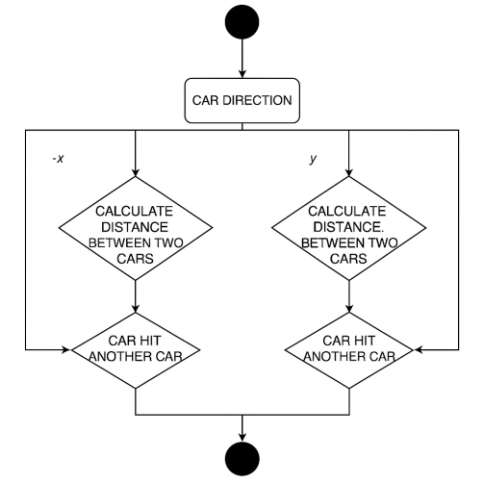
Fig. 6. Diagram of the function #carDistanceCheck()
When the work is completed, it is necessary to count the number of cars in the queues of the roads when the traffic light is red. This calculation allows you to assess the degree of congestion of the transport network and the efficiency of traffic light regulation.
To do this, the system records the number of cars that:
- stopped at the entrance to the intersection;
- did not have time to pass the intersection before the signal changed;
- accumulate in queues throughout the entire cycle of the red signal.
The collected information can be used to adjust the duration of traffic light phases, optimize traffic control algorithms, and predict future traffic congestion. The analysis of this data helps improve traffic management within a city or the transport system as a whole. In addition, the results of the calculations allow you to identify problem areas with excessive traffic accumulation, plan infrastructure changes, such as additional lanes or other measures aimed at relieving intersections. Thus, the system plays an important role in ensuring safe, smooth and efficient movement of vehicles in the urban environment. These data can also be integrated into intelligent transport systems to automatically adapt traffic light phases in real time. This allows you to reduce the average idle time of vehicles and increase the overall throughput of the intersection.
To display this process, the function #exitSignals() was developed, and its operation is shown in the diagram (Fig. 7).
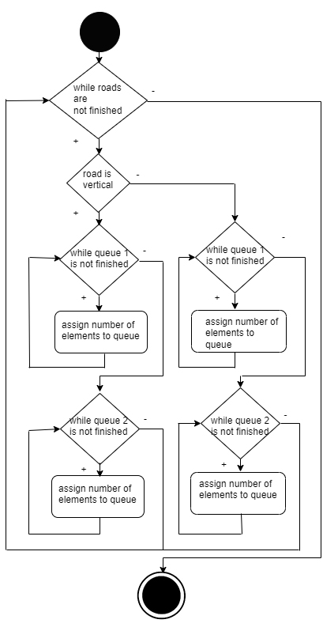
Fig. 7. Diagram of the function #exitSignals()
Analysis of results. The multimodal transport model of the city of Dnipro, developed in 2020, was taken as the model (Fig. 8).

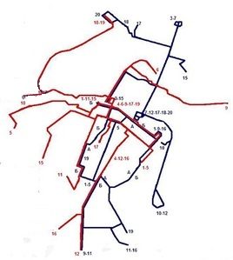
Fig. 8. Transport model of the city of Dnipro [1], [13]
During wartime, transport models of any Ukrainian cities are not made publicly available for obvious reasons.
JavaScript was chosen as the main programming language for implementing the model due to the subsequent simplicity of installing the solution into other already used systems. The web application should have the following settings:
- number of cars in the direction of the X axis;
- maximum delay of cars in the direction of the X axis;
- number of cars in the direction of the -X axis;
- maximum delay of cars in the direction of the -X axis;
- number of cars in the direction of the Y axis;
- maximum delay of cars in the direction of the Y axis;
- number of cars in the direction of the -Y axis;
- maximum delay of cars in the direction of the -Y axis;
- enable uniform distribution of cars;
- enable normal distribution of cars;
- enable decreasing distribution of cars;
- enable increasing distribution of cars;
- enabling manual filling of car distribution;
- fields for manual filling of car distribution;
- traffic light switching time.
As a result of using the web application, the following data were obtained:
- execution time;
- maximum queue of cars in the direction of the X-axis;
- maximum queue of cars in the direction of the -X-axis;
- maximum queue of cars in the direction of the -Y-axis;
- maximum queue of cars in the direction of the -Y-axis;
- distribution of cars in the direction of the X-axis;
- distribution of cars in the direction of the -X-axis;
- distribution of cars in the direction of the -Y-axis;
- distribution of cars in the direction of the -Y-axis.
Five types of car distribution were used:
1. Uniform, for which the minimum queue length was 10 cars, and the maximum was 13. To enable uniform distribution, there is a settings option in the left part of the model with the inscription "Uniform distribution of cars". There are four parameters on the left side of the web application for its configuration, which can be changed if necessary.
2. Normal, for which the minimum queue length was 23 cars, and the maximum (at rush hour) was 39. At the same time, the queues fluctuate in a certain range due to the randomness of the arrival of transport. The developed web application uses the normal distribution by default. There are 4 parameters on the left side of the web application for its configuration.
3. Decreasing (or exponential), for which the results of the experiments were consistent with each other. That is, most cases are short or moderate queues. Only sometimes longer delays can occur, but they have a very low probability. This type of distribution allows us to draw conclusions about the stability of the system under study and the repeatability of its behavior under different conditions.
4. Ascending, in which the situation is repeated as in the third descending distribution. This distribution indicates the presence of tendencies towards a gradual complication of the situation or the accumulation of phenomena, similar to the descending one, but with the opposite dynamics.
5. A distribution built on the basis of real (empirical) data.
It reflects the actual state of the system in specific conditions and is the basis for validating the model or making practical decisions.
The following input parameters were used in the experiments:
– the number of vehicles X is taken as 200 units;
– the maximum delay for the car is 1000 ms;
– the traffic light switching time is 3000 ms;
– traffic flow distribution type: uniform (activated).
The simulation results are presented below in the form of graphs (Fig. 20–23), which illustrate the dynamics of changes in key parameters during the simulation of the transport infrastructure. These graphical dependencies allow us to visualize the impact of input conditions on the efficiency of traffic light regulation and the accumulation of traffic flows. Аналіз отриманих кривих дозволяє виявити закономірності в поведінці транспортних потоків за різних умов керування та виявити потенційні вузькі місця у системі.
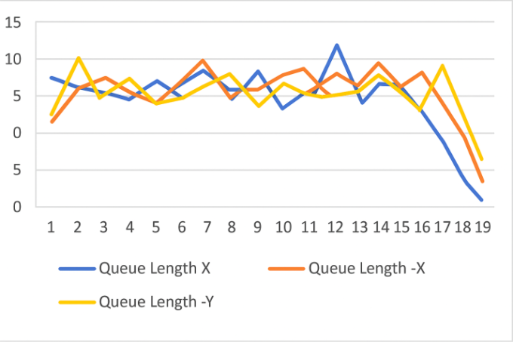
Fig. 9. Dependence of the length of the car queue under the condition of uniform traffic distribution
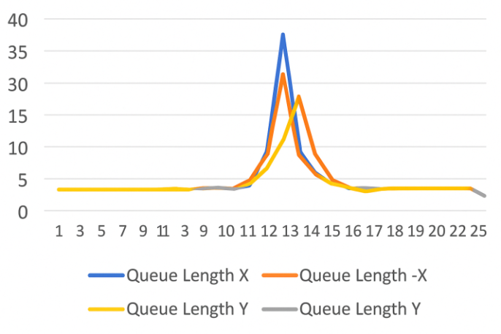
Fig. 10. Dependence of the length of the queue of cars under normal traffic distribution
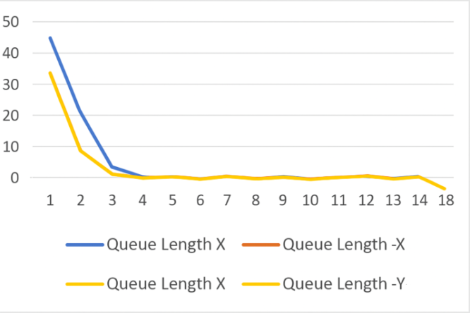
Fig. 11. Dependence of the length of the car queue under the condition of a decreasing traffic distribution
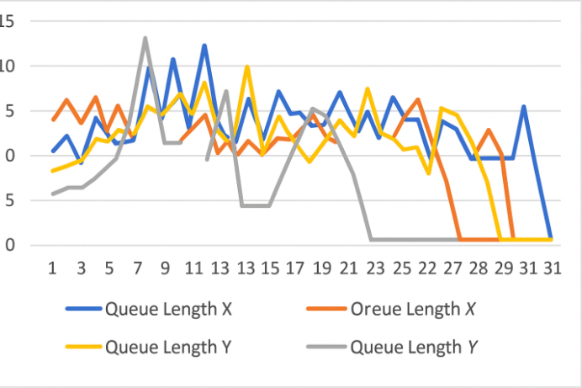
Fig. 12. Dependence of the length of the car queue under the condition of increasing traffic distribution
As can be seen from the graphs, with a uniform distribution of traffic flow, the system works up to three times faster compared to the case of normal distribution. However, in real conditions, it is impossible to ensure uniform traffic, since traffic is usually distributed according to the normal law, which leads to the formation of traffic jams. The situation can only be corrected by forced distribution according to the web application.
The introduction of a ban on left turns at intersections allows you to increase their throughput by up to two times. In addition, such a change has a positive effect on the level of traffic safety: since vehicles move exclusively straight or to the right (where there are no obstacles to maneuver), the probability of conflict situations is significantly reduced. According to statistics, the number of road accidents (accidents) at intersections is almost 8 times higher than similar indicators on straight sections of the road. Thus, it can be assumed that a ban on left turns can potentially reduce the share of accidents at intersections from 83% to 11%, which in theory means an overall reduction in accidents by 72%. At the same time, the throughput of such intersections almost doubles.
Research limitations. 1) The proposed architecture may not be effective enough when modeling complex transport systems with a large number of objects (for example, megacities). This is due to limitations in the performance of the web environment and the computing resources of the client browser; 2) the project uses external JavaScript/Java libraries (for graph construction or visualization). Changes or disappearance of these libraries may affect the functionality and support of the system; 3) due to the complexity of the visual representation and interaction with the graphical editor, the web application may not fully function on smartphones or tablets; 4) the models do not take into account social, psychological or informal factors that may affect traffic. For example, behavioral aspects of drivers.
Practical significance.
1. The functional prototype allows you to simulate transport scenarios in real time and can be used: a) by government agencies, city administrations and project organizations for a visual representation of the transport network before their practical implementation; b) as a tool for preliminary testing of new schemes for optimizing transport flows, which allows you to minimize risks during the actual implementation of changes to the transport infrastructure.
2. It combines modularity, flexibility and accessibility, which allows it to be used as a platform for further research in the field of simulation modeling of transport processes.
3. Implemented as a web application, providing accessibility from any device with a browser.
4. The architecture is a promising basis for integration with smart city systems and IoT solutions, where fast visualization and modeling of road flows based on real-time data is required.
5. Given the modular structure of the developed system, it can be expanded with new functional blocks - in particular, to take into account environmental factors, predict emergency situations, weather conditions, driver reactions or calculate the level of street congestion.
6. Can be used in the military sphere for:
- simulation of military columns, equipment supply, evacuation;
- analysis of logistical routes for the delivery of ammunition, fuel, medical resources;
- determination of optimal routes taking into account congestion, destroyed infrastructure or checkpoints;
- as a tool for building routes in difficult conditions (lack of mobile communication, GPS interference);
- as part of the decision-making system in the headquarters;
- simulation of real-time situations: road closures, enemy ambushes, rapid transfer of forces;
- modeling of actions under shelling, damage to bridges, blocking routes;
- planning the transfer of forces and assets to new areas of the front with maximum efficiency and minimal risk.
In integration with unmanned systems or satellite imagery, such a system can:
- monitor traffic in real time;
- assess road conditions or the presence of obstacles;
- control unmanned vehicles or even autonomous vehicles, etc.
Thus, routing algorithms and vehicle movement simulation in combination with modern analytical systems can become an important tool for digital logistics and operational management in wartime.
Conclusions. The developed web application is designed for simulation modeling of road traffic at an intersection in order to analyze and increase its throughput. The software tool is characterized by a simple and accessible interface, understandable at an intuitive level. This ensures its use even by users with minimal technical skills, and also allows implementing the system with minimal time and financial resources. To build the software architecture, a modular-component approach was used, which allows for effective distribution of functionality by logical blocks (simulation module, data processing, visualization, query management, etc.).
As an architectural style, a three-tier architecture was chosen, which involves dividing the system into: presentation level (frontend) - implemented using modern web technologies (HTML/CSS/JavaScript, React/Vue libraries); logic level (backend) – implemented in Python, which provides query processing and simulation calculations; data layer (database) – a repository for geospatial data, infrastructure parameters and modeling results. The simulation mechanism is based on an agent-oriented approach, which allows modeling the interaction of individual road users taking into account their characteristics and behavioral models. The web application is implemented using RESTful API, which provides scalability, support for various clients (web, mobile devices) and flexibility in expanding the functionality. The research is aimed at improving the efficiency of intersections with traffic light control using the proposed traffic simulation modeling system, obtained on the basis of the transport model of the city of Dnipro. Thanks to its application, it became possible to optimize the parameters of traffic light regulation, which allows significantly increasing the throughput of the intersection and reducing congestion
The results of the study can be used in the work of municipal departments or private enterprises engaged in the organization and transport planning of urban transport infrastructure. The developed model can be adapted for different types of transport systems - from automobile to pedestrian traffic. In the military sphere, the web application can serve as a tool for situational analysis, logistics planning and simulation for making effective decisions in dynamic and dangerous conditions.
In the future, this software tool and the web application obtained during its implementation can be improved by expanding its areas of application and adding more flexible settings for roads.

References
- Bespalov, D., Tarasiuk, V., & Myroshnychenko, O. (2020). Transportna model mista Dnipro ta yoho prymiskoi zony [Transport model of the city of Dnipro and its suburban area: presentation]. [Online]. Available: https://www.slideshare.net/slideshow/transport-model-of-dnipro-city/218415930. [Accessed: Apr. 17, 2025] (in Ukrainian).
- Buhaiov I. S., Kholodova O. O., & Buhaiova M. O. (2023). Otsinka efektyvnosti vprovadzhennia zasobiv zaspokoiennia dorozhnoho rukhu na perekhresti [Assessment of the effectiveness of implementing traffic calming measures at intersections]. Suchasni tekhnolohii v mashynobuduvanni ta transporti, 20, 79-86. [Online]. Available: https://eforum.lntu.edu.ua/index.php/jurnal-mbf/article/view/1036.9. [Accessed: Apr. 22, 2025] (in Ukrainian).
- Cherednichenko, К. V. (2022). Urban transport network optimization modeling in integrated transport systems [Modeling urban transport network optimization in integrated transport systems]. Dorogi і mosti. Kyiv, 25, 259–269. [Online]. Available: https://doi.org/10.36100/dorogimosti2022.25.259. [Accessed: Apr. 20, 2025] (in Ukrainian) (in Ukrainian).
- Dasgupta, S., Rahman, М., & Jon, S. (2023). Harnessing Digital Twin Technology for Adaptive Traffic Signal Control. Computer Science (Networking and Internet Architecture), 1 Jul. [Online]. Available: https://doi.org/10.48550/arXiv.2309.16673. [Accessed: Apr. 19, 2025] (in English).
- Dzyhar, V. (2023). Informatsiina tekhnolohiia modeliuvannia trafiku dorozhnoho rukhu za dopomohoiu multyahentnykh system [Information technology for road traffic modeling using multi-agent systems]: Mahisterska dys. Vinnytsia: VNTU, 89 s. [Online]. Available: https://iq.vntu.edu.ua/repository/getfile.php/7652.pdf [Accessed: Apr. 17, 2025] (in Ukrainian).
- Horbova, O. V., & Merzlyi, O. D. (2021). Doslidzhennia avtomobilnykh potokiv zasobamy imitatsiinoho modeliuvannia [Research of automobile flows using simulation modeling]. Nauka ta prohres transportu, 5(95), 36–45. [Online]. Available: https://crust.ust.edu.ua/server/api/core/bitstreams/cab4c390-7902-42c8-8df3-9b9d9b35d599/content. [Accessed: Apr. 25, 2025] (in Ukrainian).
- Khitrov, I. O. (2023). Otsinka efektyvnosti funktsionuvannia perekhrestia z kruhovym rukhom [Evaluation of the effectiveness of the functioning of a roundabout]. Suchasni tekhnolohii v mashynobuduvanni ta transporti, 2(21), 227-235. [Online]. Available: https://eforum.lntu.edu.ua/index.php/jurnal-mbf/article/view/1228. [Accessed: Apr. 17, 2025] (in Ukrainian).
- Kompaniia «A+S Ukraina». Transportni modeli [Transport models], 2019. [Online]. Available: https://hmarochos.kiev.ua/2015/12/17/transportna-model-kiyeva-instrument-zmin-u-misti/ [Accessed: Apr. 11, 2025] (in Ukrainian).\
- Liashuk, O. L., Stashkiv, O. P., Tson, N. Ya., Rozhko, U. M. Plekan, B. R., & Hevko, M. Ya. (2023). Pidvyshchennia efektyvnosti funktsionuvannia nerehulovanoho perekhrestia z kruhovym rukhom [Improving the efficiency of an unregulated roundabout]. Tsentralnoukrainskyi naukovyi visnyk. Tekhnichni nauky, 8(39), ch. I, 219-229. [Online]. Available: https://mapiea.kntu.kr.ua/archive/39_I/39_I_Lyashuk3.html8. [Accessed: Apr. 10, 2025] (in Ukrainian).
- Lv, P., Pei, Х., Ren, Х., Zhang, Y., Li, С., & Xu, М. (2022). TraInterSim: Adaptive and Planning-Aware Hybrid-Driven Traffic Intersection Simulation. Computer Science. Robotics, 3 Oct. [Online]. Available: https://doi.org/10.48550/arXiv.2210.08118. [Accessed: Apr. 27, 2025] (in English).
- Lytvyn, V., Melnikova, Yu., & Lazutkyn, M. (2024). Kilkisna otsinka efektyvnosti zminy skhemy rukhu na perekhresti vul. Kalynova – pr. P. Kalnyshevskoho (m. Dnipro) [Quantitative assessment of the effectiveness of changing the traffic pattern at the intersection of Kalinova St. - P. Kalnyshevsky Ave. (Dnipro city)]. Suchasni tekhnolohii v mashynobuduvanni ta transporti, 1(22), 222-232. https://doi.org/10.36910/automash.v1i22.1364. [Online]. Available: https://eforum.lntu.edu.ua/index.php/jurnal-mbf/article/view/1364/1230. [Accessed: Apr. 23, 2025] (in Ukrainian).
- Mormul, M. F., Firsov, O. D., Ulianovska, Yu. V., & Pikulin, D. O. (2022). Proektuvannia arkhitektury veb-zastosunku dlia imitatsiinoho modeliuvannia upravlinnia transportnymy potokamy [Designing a web application architecture for traffic flow management simulation modeling]. Systemy ta tekhnolohii. 1 (63), 70-87. [Online]. Available: http://biblio.umsf.dp.ua/jspui/bitstream/123456789/5332/1/86-Article%20Text-162-1-10-20230315.pdf [Accessed: Apr. 01, 2025] (in Ukrainian).
- Moroz, Ye. (2019). Transportnaia model horoda Dnepr [Transport model of the city of Dnepr]. 2019. [Online]. Available: https://dengi.informator.ua/2019/11/28/v-dnepre-predstavili-transportnuyu-model-goroda-chto-eto-dast-gorozhanam/. [Accessed: Apr. 13, 2025] (in Russian).
- Nerush, V. B, & Kurdech, V. V. (2012). Imitatsiine modeliuvannia system ta protsesiv [Simulation modeling of systems and processes]. Kyiv: NTUU «KPI». 115 s. [Online]. Available: https://ela.kpi.ua/items/f07a7684-b38c-462d-9b29-8506c7c9298e. [Accessed: Apr. 10, 2025] (in Ukrainian).
- Pitsyk, M. H. (2012). Vdoskonalennia konkursnoi metodyky otsinky pereviznykiv pry vybori avtobusiv na marshrut [Improving the competitive methodology for evaluating carriers when selecting buses for a route]. Upravlinnia proiektamy, systemnyi analiz i lohistyka. Tekhnichna seriia, 157 s. (in Ukrainian).
- Ranpura, Р., Gujar, R., & Singh, S. (2025). Development of Mixed Traffic Microsimulation Model Calibration for Heterogeneous Traffic Conditions. Transportation Research Procedia, 2898-2910. . [Online]. Available: https://doi.org/10.1016/j.trpro.2024.12.226. [Accessed: Apr. 24, 2025] (in English).
- Riabushenko, O. V., & Prosvirnin, O. V. (2023). Modeliuvannia rukhu povorotnoho potoku na rehulovanomu perekhresti. Visnyk Kharkivskoho natsionalnoho avtomobilno-dorozhnoho universytetu, vol. 1, 101, 156-161. [Online]. Available: https://doi.org/10.30977/BUL.2219-5548.2023.101.0.156. [Accessed: Apr. 26, 2025] (in Ukrainian).
- Ruti, R., & Tanyel, S. (2025). Developing a Sustainable Traffic Management Framework Using Machine Learning Algorithms. Sustainability (Sustainable Transportation), 17(3). [Online]. Available: https://www.mdpi.com/2071-1050/17/3/1267. [Accessed: Apr. 20, 2025] (in English).
- Verhunova, I. M. (2016), Systemne modeliuvannia v ekonomitsi [System modeling in economics]. Kyiv: TOV «Nash format», 134 s. [Online]. Available: https://csc.knu.ua/uk/library/books/vergunova-39.pdf. [Accessed: Apr. 13, 2025] (in Ukrainian).
- Zang, С., Turkcan, М. К., Zussman, Gil, Ghaderi, Javad, & Kostic, Z. (2024). Data-Driven Traffic Simulation for an Intersection in a Metropolis. Computer Vision and Pattern Recognition, 1 Aug. [Online]. Available: https://arxiv.org/abs/2408.00943. [Accessed: Apr. 18, 2025] (in English).

